Environment Setup, Project Structure & First Component

Task 1: Scaffold and Explore the Angular Project
Goal: Create the Angular workspace and understand what each generated file does.

Project initialization

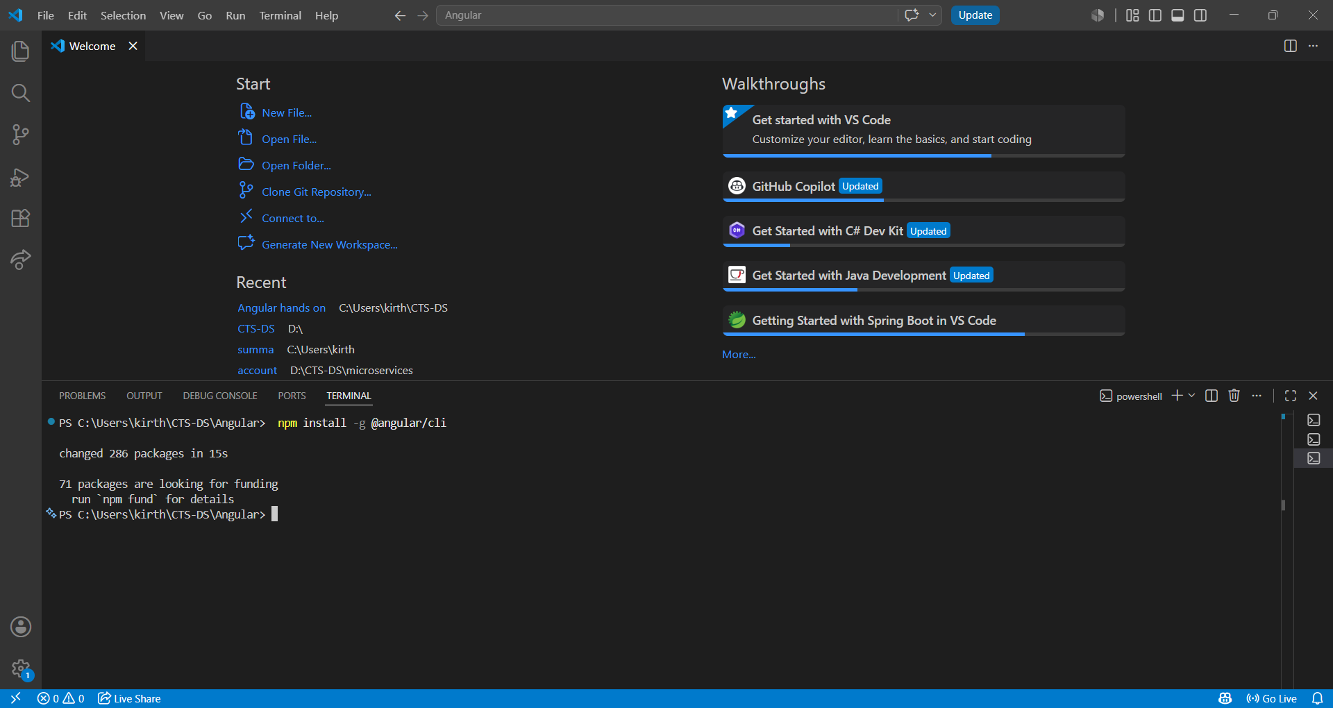
Student-course portal Creation
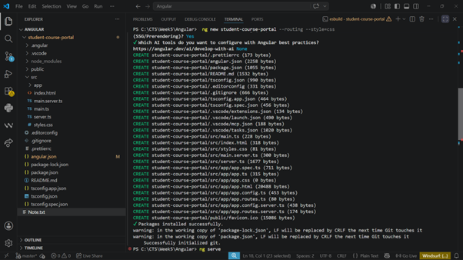

Notes.txt
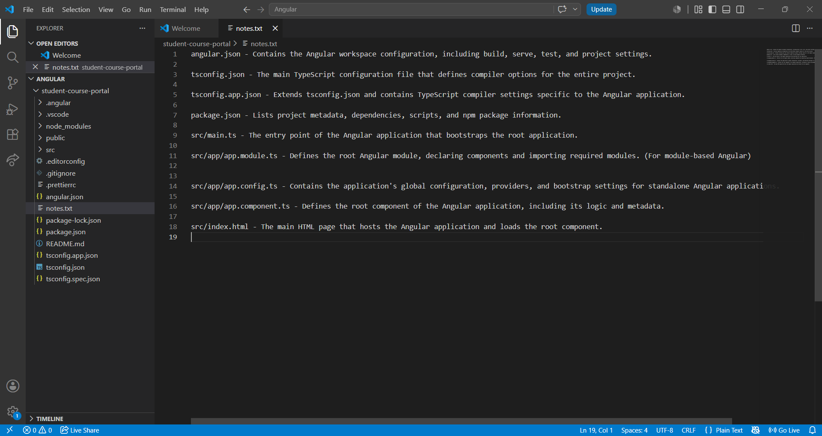

Run the project:
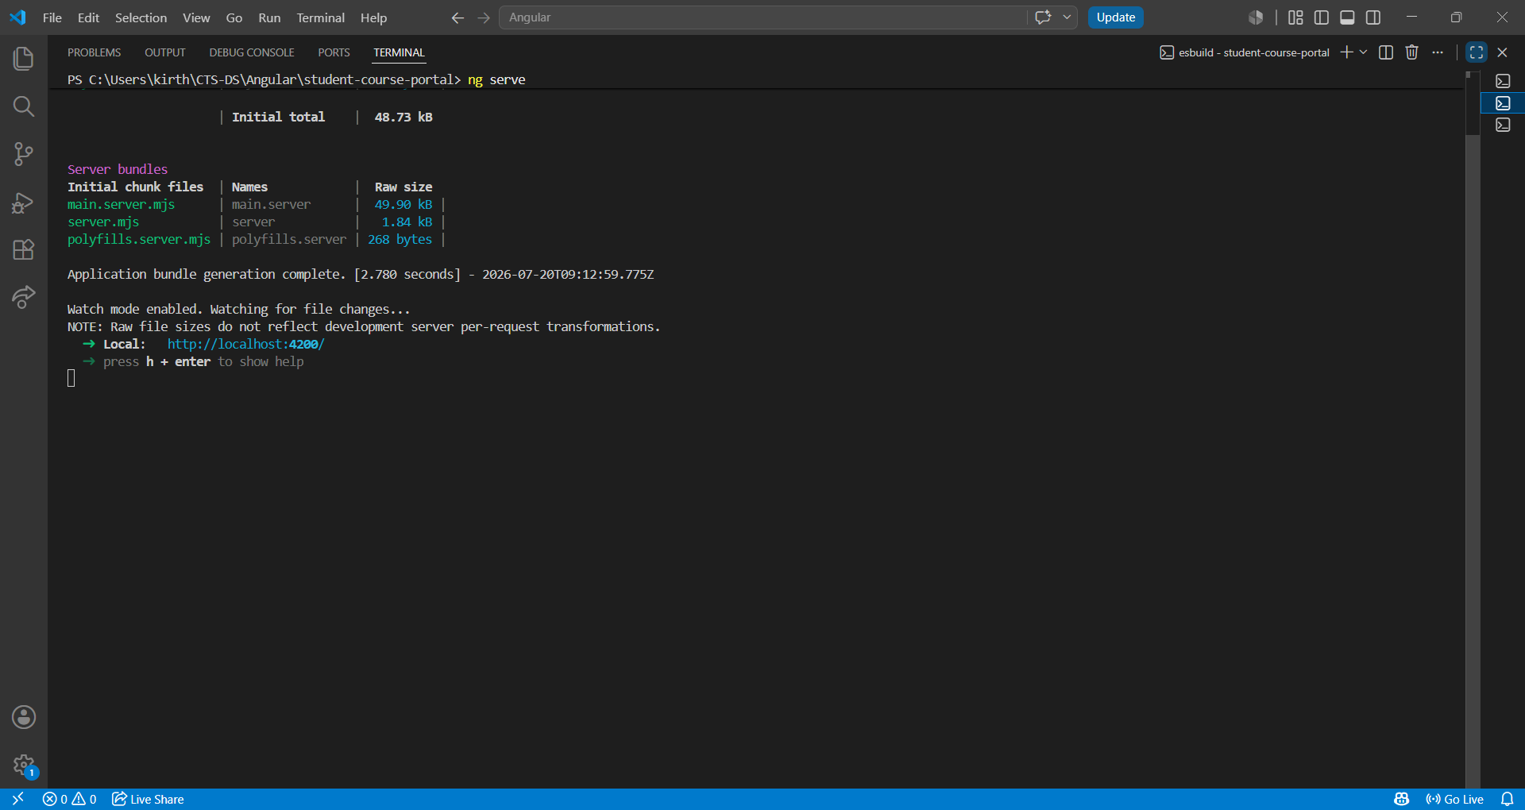
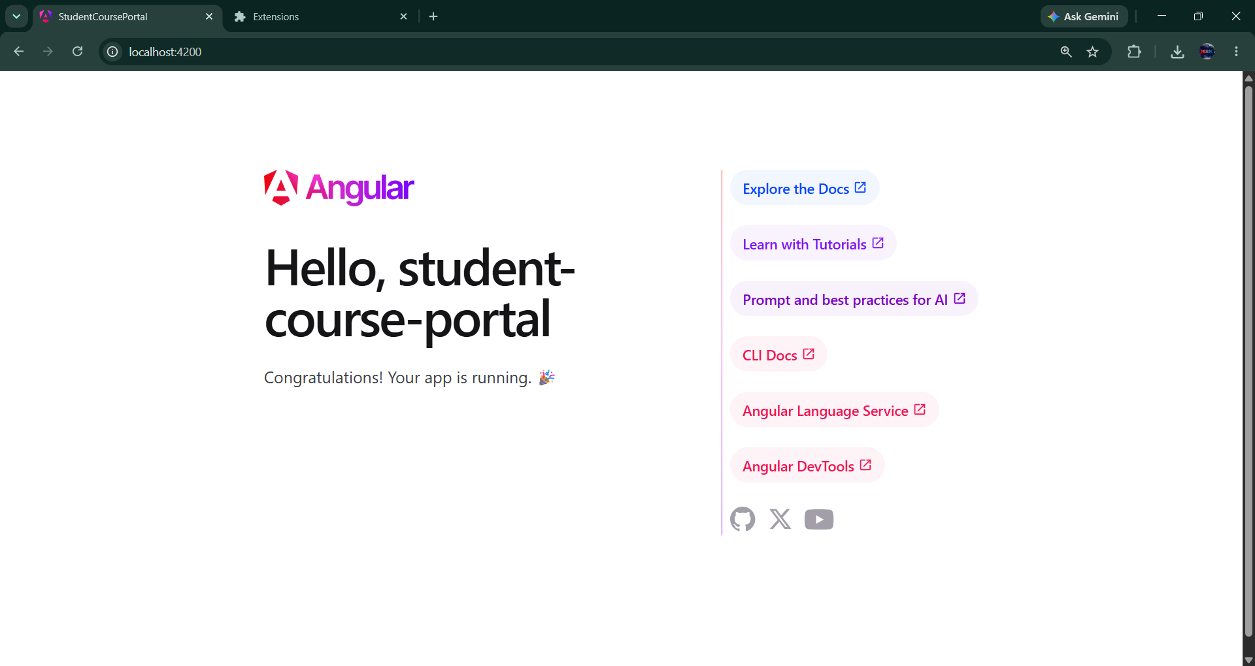

Task 2: Create and Organise Components
Goal: Generate the core page components for the Student Course Portal
Generating components
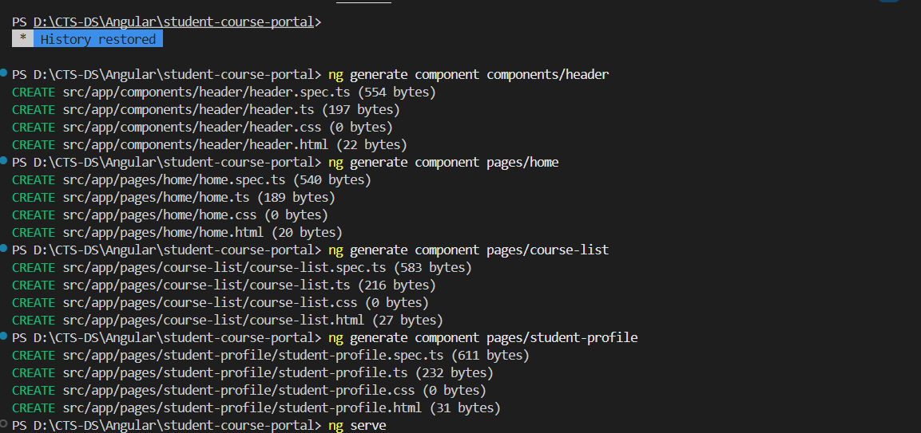

Header component
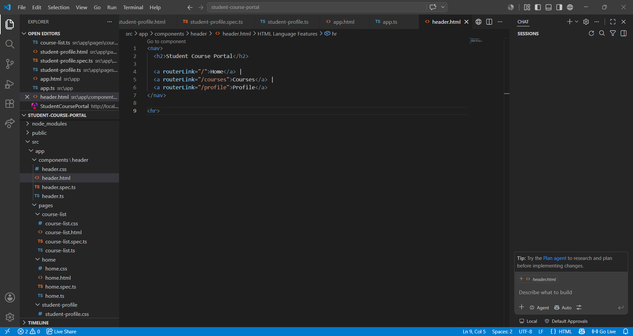
Home.html
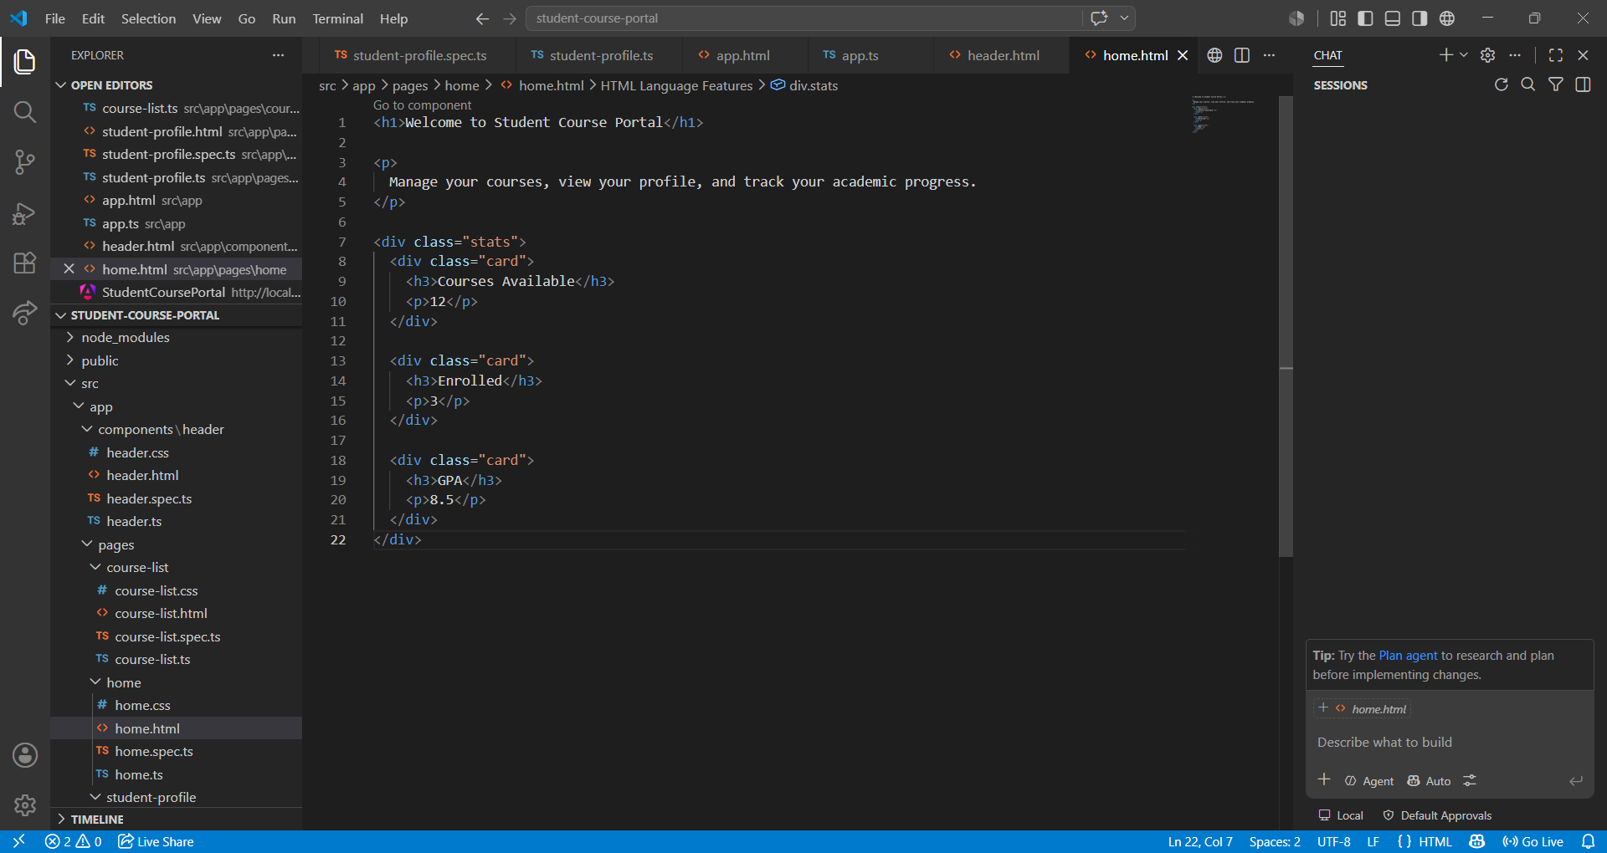
Adding app header and router outlet
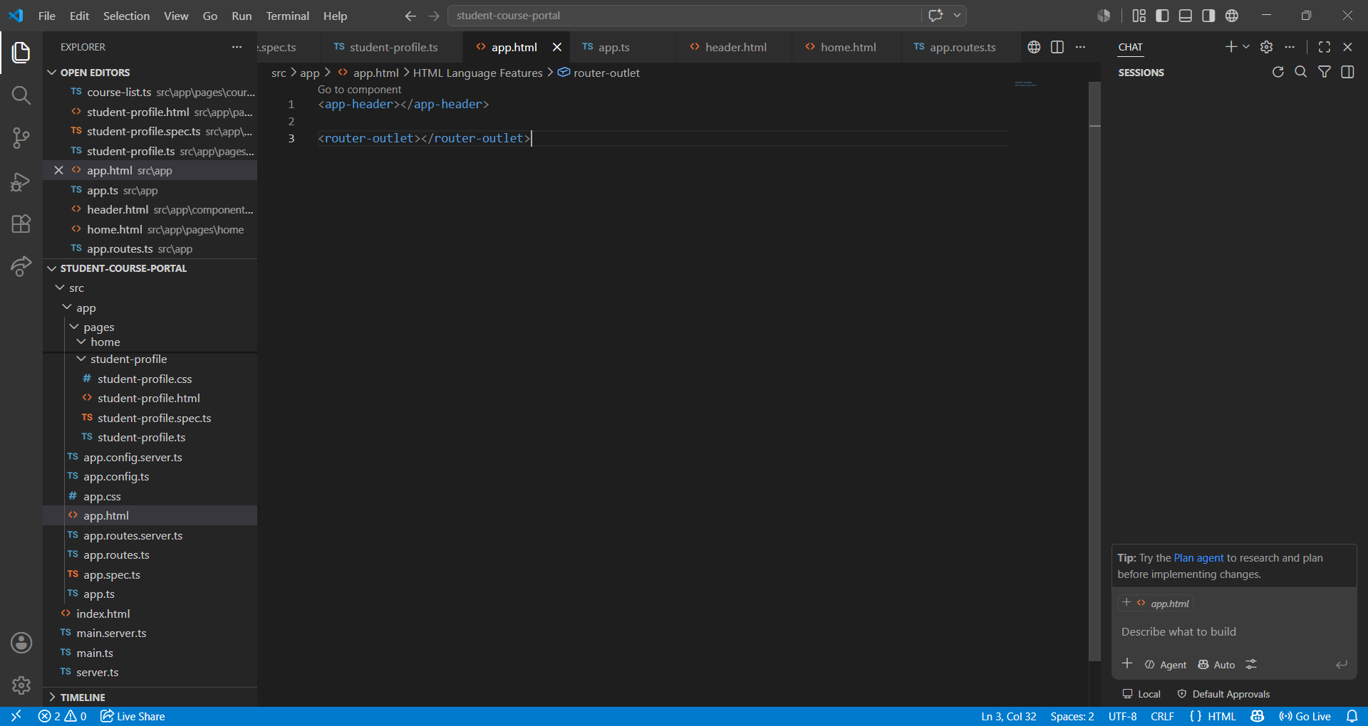

Output:
